Assignment 2

**Creating an EC2 instance.**

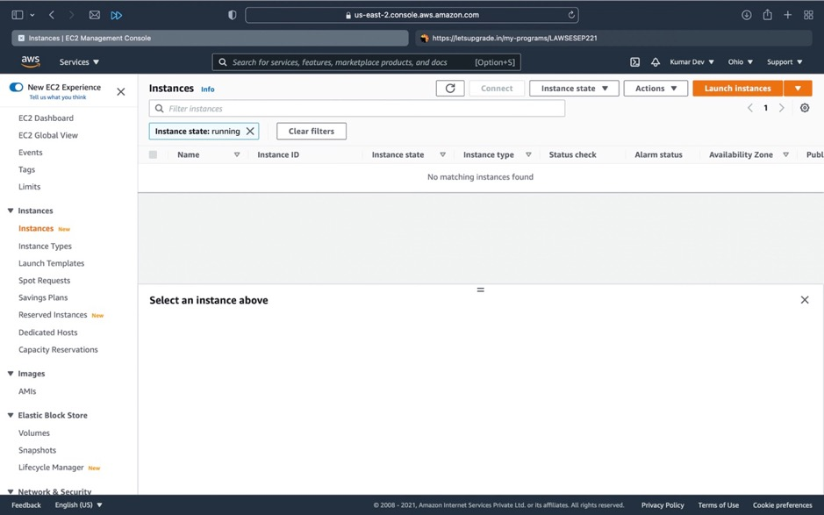

Here is the list of instances present.

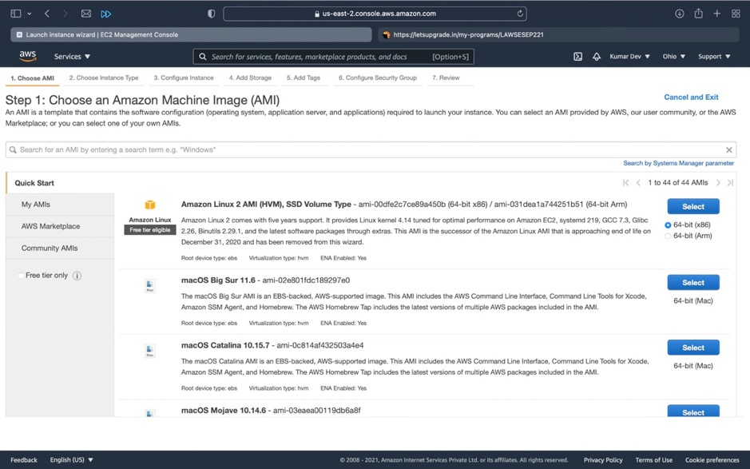

Here we have to select an Amazon Machine Image.

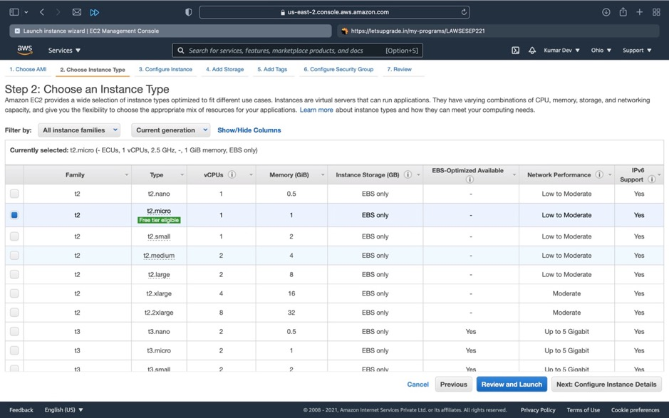

Choose an Instance type here, select free tier eligible to avoid extra charges.

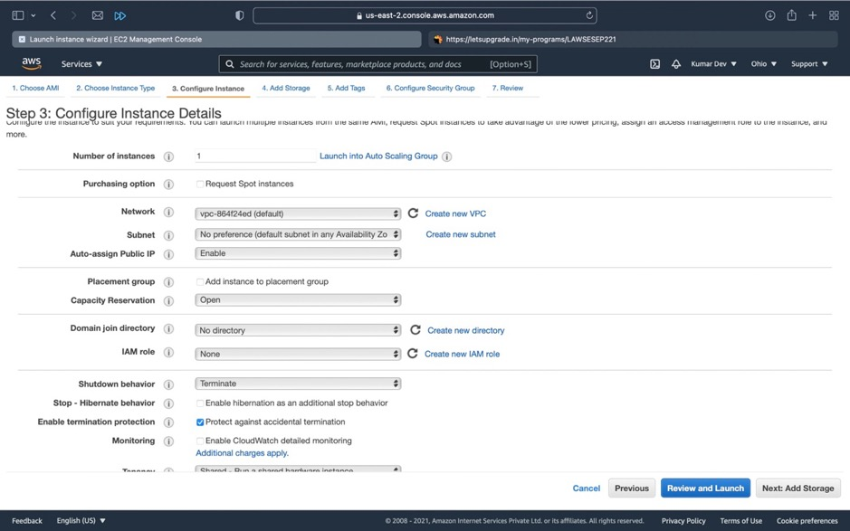

Here we have to configure Instance details and have to enabled termination protection.

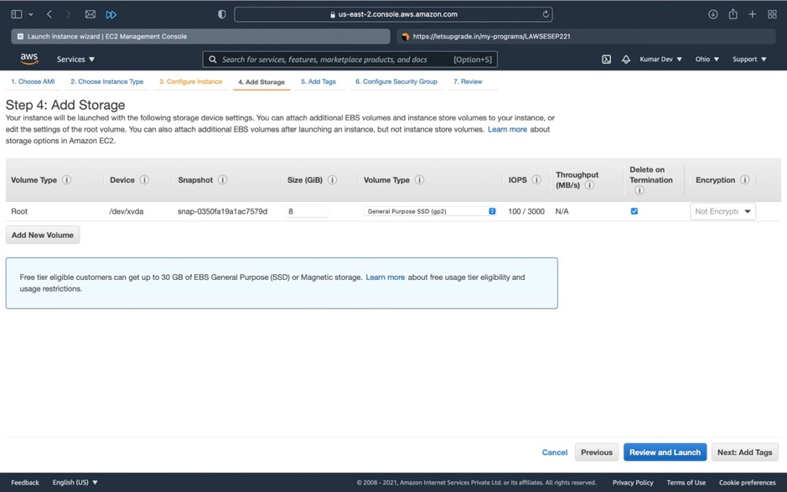

Here we can attach additional EBS volume to the instance.

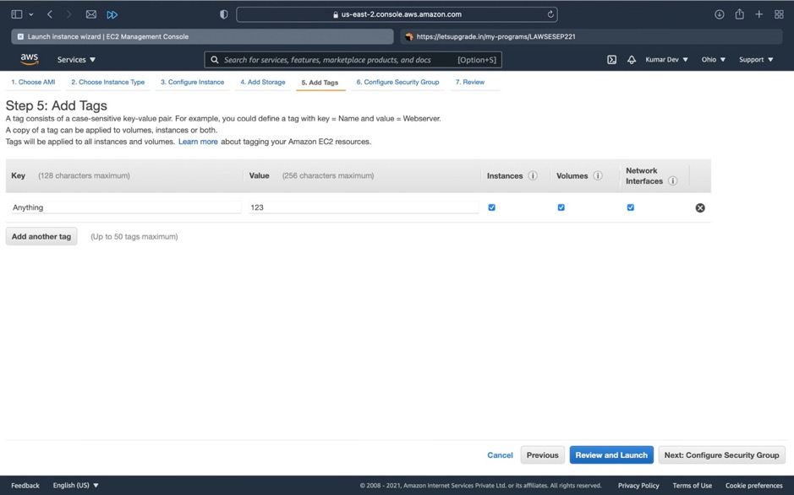

Here we can add Tags to the Instance.

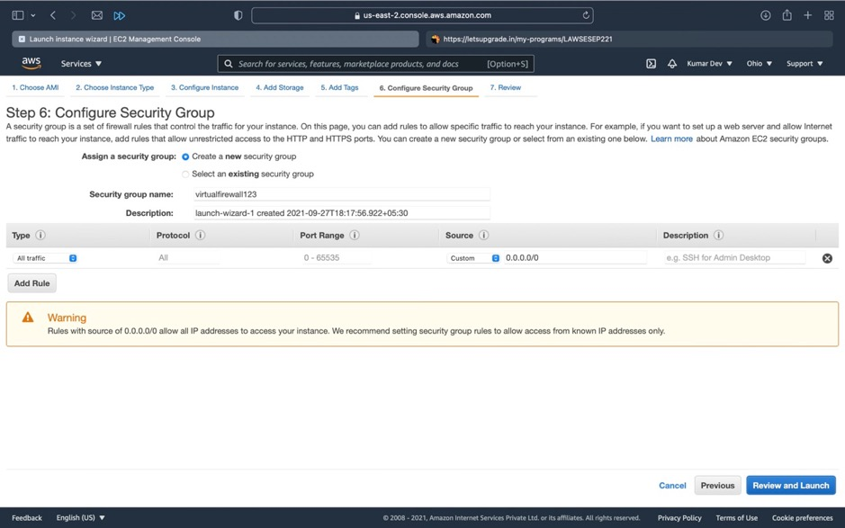

Here we have to configure security groups and to give a security group name.

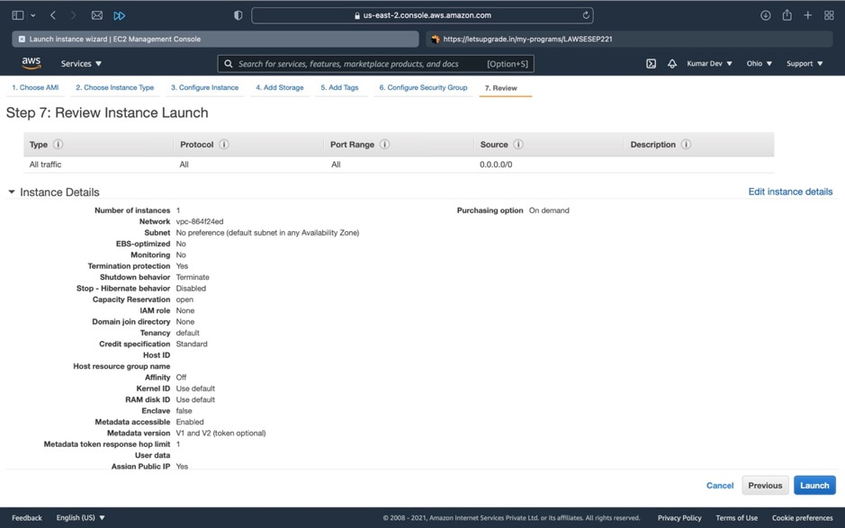

This is the instance details.

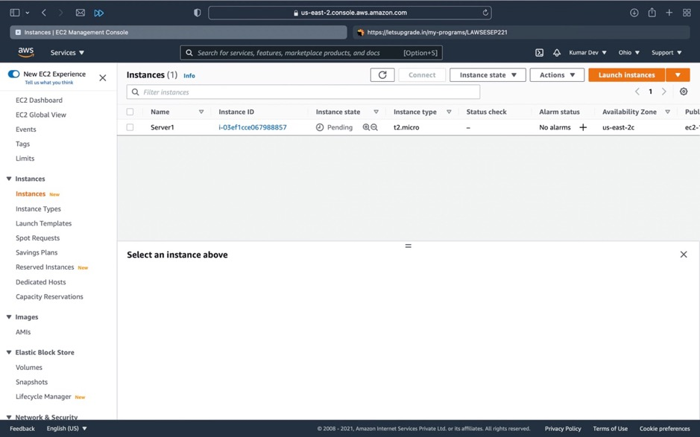

Here is the Instance that I have made.

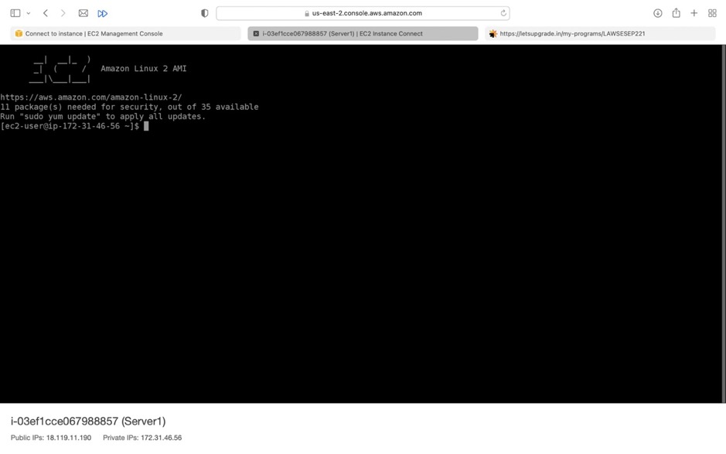

This is the instance Console and give sudo yum update to install update

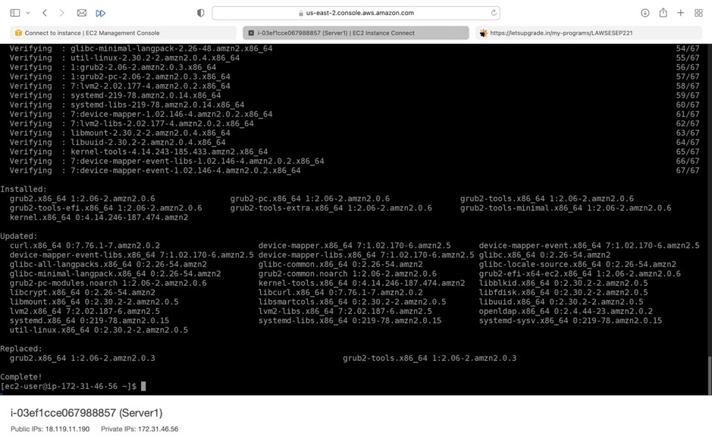

Finally updates are applied.

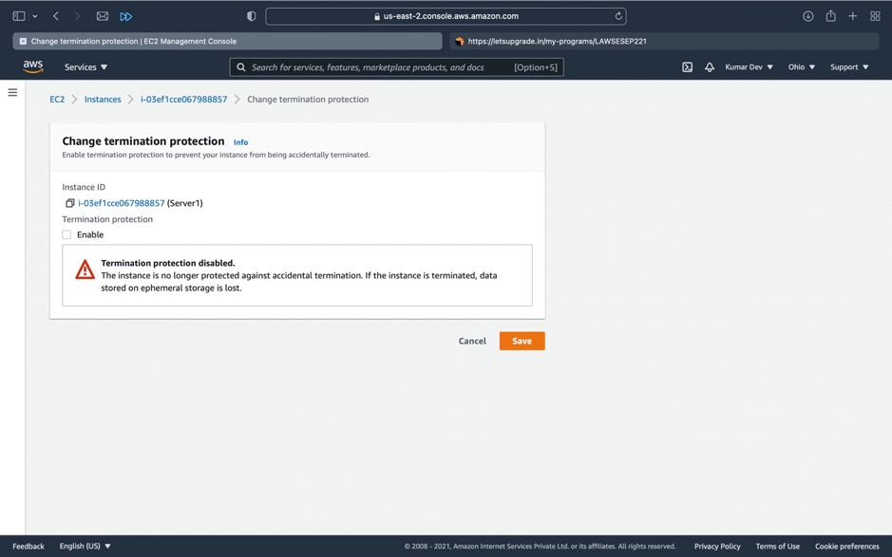

Here I have disabled termination protection for a particular instance.

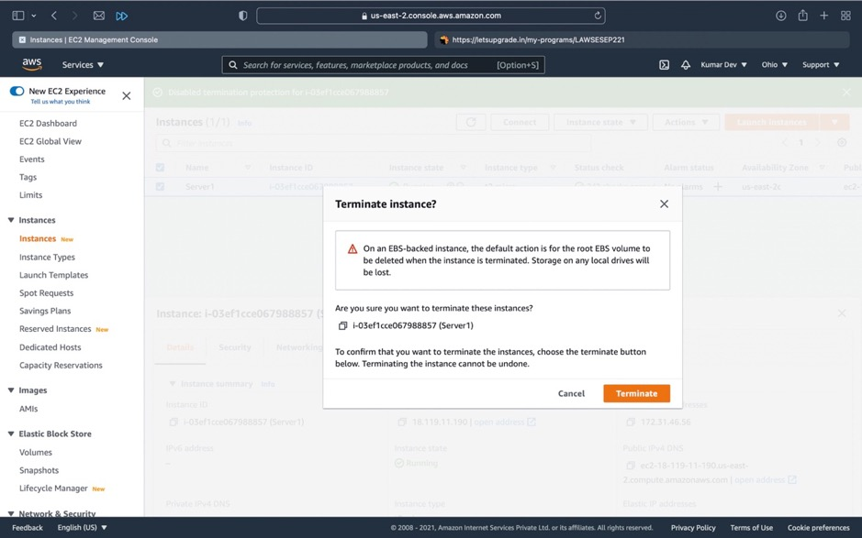

Click on terminate instance for terminating the instance.

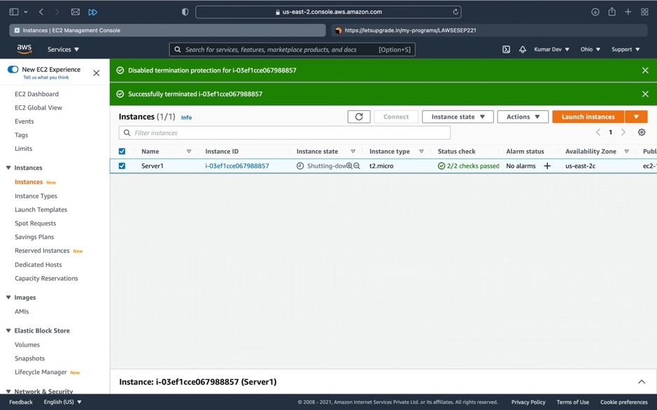

Finally the instance is successfully terminated.